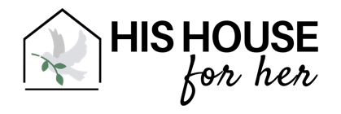
SERVICES

During a woman’s season at His House for Her, our goal is to remove the physical, emotional, and spiritual barriers that keep her from healing, becoming whole, and transforming her life.

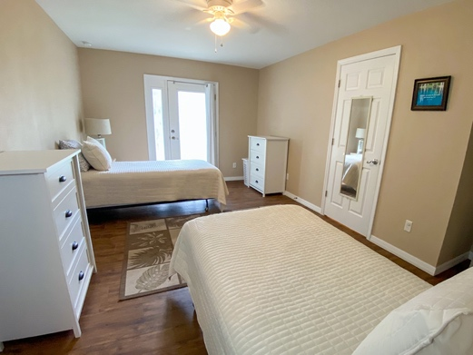
OUR SERVICES INCLUDE:
Safe, clean, comfortable housing.
24/7 Supervision.
Trauma-informed Practices and Staff.
Targeted Case Management.
We accept and support residents on MAT.
We provide after-care planning.
We provide random 13-panel drug screens
for residents.
We help residents obtain ACCESS Florida benefits.
We help residents obtain educational opportunities.
We help residents obtain employment readiness services.
Transportation for all appointments and employment.
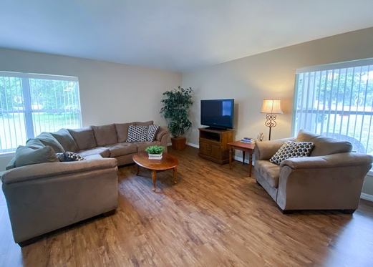
We help residents meet their drug court requirements.
We help residents obtain mental health, medical, dental, optical, and addiction services.
We facilitate and provide supervision for family visits per case plans.
We help residents overcome barriers to working Dependency and Drug Court case plans.

OUR EDUCATIONAL OPPORTUNITIES INCLUDE:
Addiction recovery, Relapse prevention and
Trauma-informed care.
Conflict resolution.
Basic life skills: healthy self-care. chores, meal
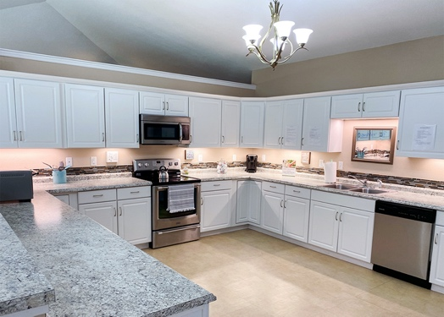
planning, laundry, and healthy diet and exercise.
Budgeting and financial management.
Healthy parenting, relationships, and boundaries.

FOR SPIRITUAL HEALING WE PROVIDE:
Church attendance.
Women’s conferences.
Christ-centered studies and prayer.

